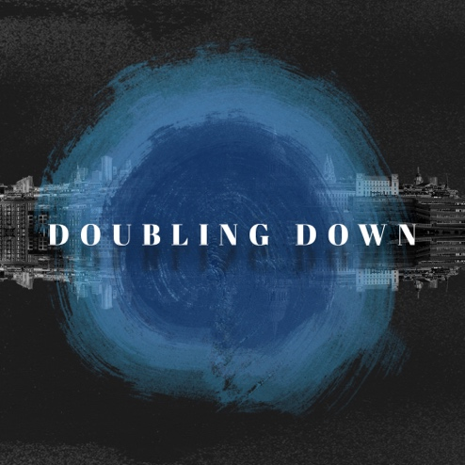

Doubling Down – Week 1 – Biblical Authority
Spiritual Formation Guide

Make no mistake – we are in the Bible business and we’re doubling down on the conviction that its authority in our lives is more necessary than ever. Simply stated – we trust the Bible in all things. Even when it’s unpopular.

Your word is truth.
John 17:17

All Scripture is inspired by God and is useful to teach us what is true and to make us realize what is wrong in our lives. It corrects us when we are wrong and teaches us to do what is right.
2 Timothy 3:16

Don’t just listen to listen to God’s word. You must do what it says. Otherwise, you are just fooling yourselves.
James 1:22

The word of God is alive and powerful. It is sharper than the sharpest two-edged sword, cutting between soul and spirit, between joint and marrow. It exposes our innermost thoughts and desires.
Hebrews 4:12

We are human, but we don’t wage war as humans do. We use God’s mighty weapons, not worldly weapons, to knock down the strongholds of human reasoning and to destroy false arguments. We destroy every proud obstacle that keeps people from knowing God. We capture their rebellious thoughts and teach them to obey Christ.
2 Corinthians 10:3-5

We won’t be tossed and blown about by every wind of new teaching. We will not be influenced when people try to trick us with lies so clever they sound like the truth. Instead, we will speak the truth in love, growing in every way more and more like Christ, who is the head of his body, the church.
Ephesians 4:14

You should know this, Timothy, that in the last days there will be very difficult times. For people will love only themselves and their money. They will be boastful and proud, scoffing at God, disobedient to their parents, and ungrateful. They will consider nothing sacred. They will be unloving and unforgiving; they will slander others and have no self-control. They will be cruel and hate what is good. They will betray their friends, be reckless, be puffed up with pride, and love pleasure rather than God. They will act religious, but they will reject the power that could make them godly.
2nd Timothy 3:1

This is a terrific responsibility. Is anyone competent to take it on? No—but at least we don’t take God’s Word, water it down, and then take it to the streets to sell it cheap. We stand in Christ’s presence when we speak; God looks us in the face. We get what we say straight from God and say it as honestly as we can.
2 Corinthians 2:17 (MSG)

Discussion and Reflection Questions:
- Icebreaker: What’s something that you believe in strongly, that no one can change your mind? (It can be an opinion on anything – doesn’t have to be serious or spiritual.)
- Eddie shared a core belief for our church: We trust the Bible. How do you react to that statement? What emotions or questions or thoughts come to your mind?
- Read Jesus’ words in John 17:17. How does that speak to the things you just shared with one another?
- Read 2 Timothy 3:16. How does it describe the power of Scripture? How have you experienced this?
- How do you naturally react to authority? (Make space for different personalities to express their perspective.)
- What’s your reaction to God’s authority over your life? Where is it difficult for you to accept it?
- Take some time to have someone (or several people) read the scripture passages above out loud, one after another. What do you notice? Is there a reminder that you sense God wants you to hold onto?

28 Days of Prayer
November 7 – December 4, 2021
As a church family, we are going to spend the coming weeks intentionally praying together.
You can download the full prayer guide as a pdf here.
Want to receive prompts each day by text or email? Visit www.wschurch.org/pray to sign up.

